Smart StockFlow – Warehouse Management System
Comprehensive Project Report
Project Name: Smart StockFlow WMS
Client: BEUMER Group – Haryana Plant
Technology Stack: MERN (MongoDB, Express, React, Node.js)
Development Period: 2024
Version: 1.0.0
Report Date: December 18, 2025

Table of Contents
- Executive Summary
- System Overview
- Technical Architecture
- Features and Functionality
- Database Design
- API Documentation
- User Interface
- Security Implementation
- Testing and Quality Assurance
- Deployment and Configuration
- Known Issues and Resolutions
- Future Enhancements
- Conclusion
Appendices

1. Executive Summary
Smart StockFlow is a full-stack Warehouse Management System (WMS) developed for BEUMER Group’s Haryana Plant. The system enables real-time inventory tracking, transaction auditing, order fulfillment, quality inspection, and sustainability monitoring using a modern MERN-based architecture.
Key Achievements
- Complete CRUD operations for materials, locations, and inventory
- Real-time dashboard with live KPIs and analytics
- Robust transaction system with full audit trail
- Role-based access control (Admin, Supervisor, Operator, Engineer)
- GST-compliant pricing and automated tax calculations
- Sustainability tracking with CO₂ impact metrics
- Integrated quality inspection workflows
- Order fulfillment with picking, packing, and shipping modules
Business Impact
- Inventory Accuracy: Real-time tracking with reserved quantity management
- Operational Efficiency: Automated workflows reduce manual errors
- Compliance: Built-in GST calculations and audit trails
- Sustainability: Environmental impact monitoring for reporting
- Scalability: Architecture ready for conveyor and IoT integration
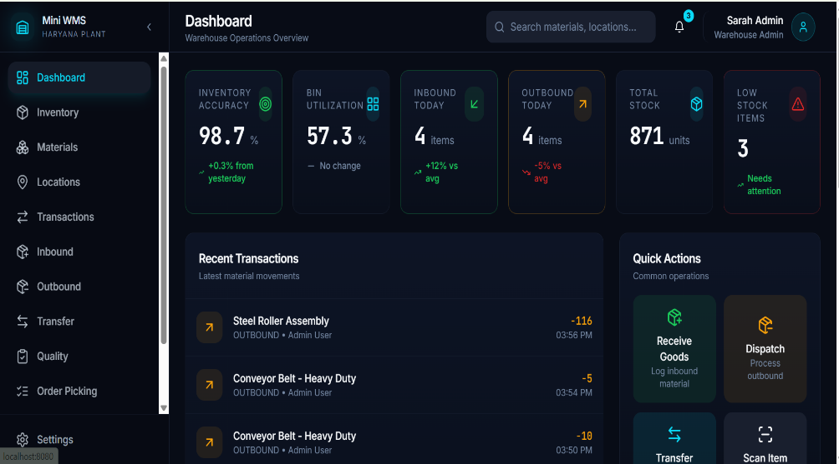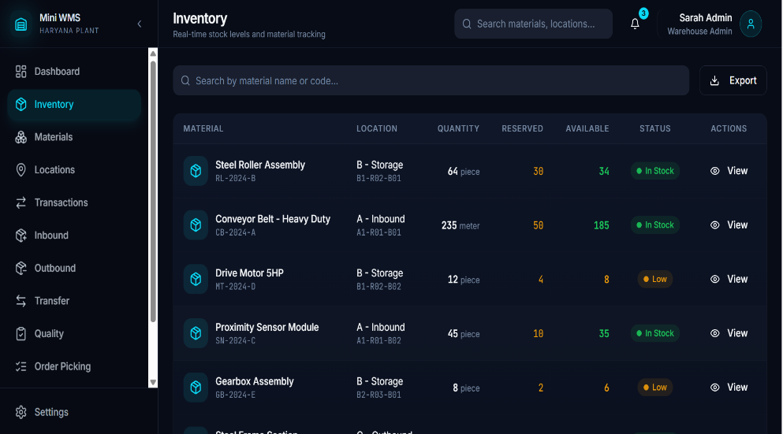

2. System Overview
2.1 Purpose and Scope
Smart StockFlow addresses the need for efficient warehouse operations by managing:
- Material inventory across multiple categories
- Hierarchical storage locations
- Inbound, outbound, transfer, and adjustment transactions
- Quality inspections and compliance checks
- Order processing from picking to shipment
2.2 System Architecture
The system follows a three-tier architecture:
- Frontend Layer: React 18, TypeScript, TailwindCSS, shadcn/ui
- Backend Layer: Node.js, Express.js, REST APIs, JWT authentication
- Data Layer: MongoDB with Mongoose ODM
2.3 Technology Stack
Frontend: React, TypeScript, Vite, TailwindCSS, React Query, Axios, Recharts
Backend: Node.js, Express, MongoDB, Mongoose, JWT, bcrypt, Joi, Morgan
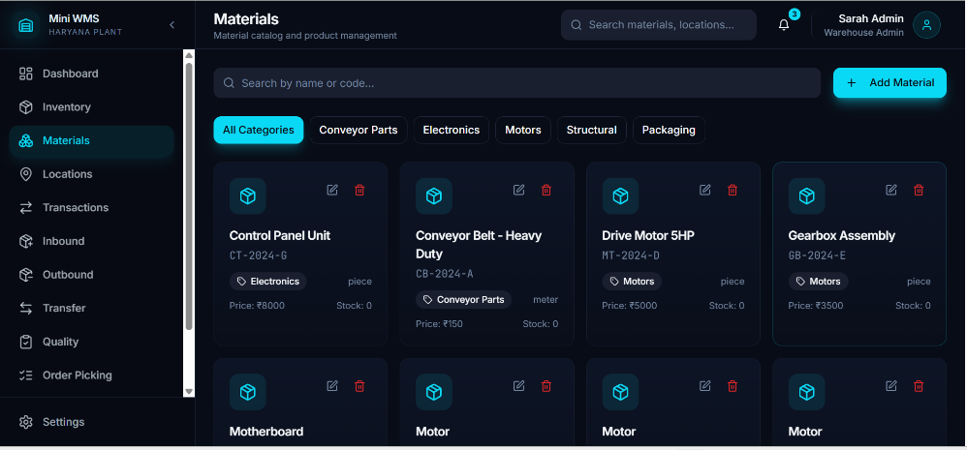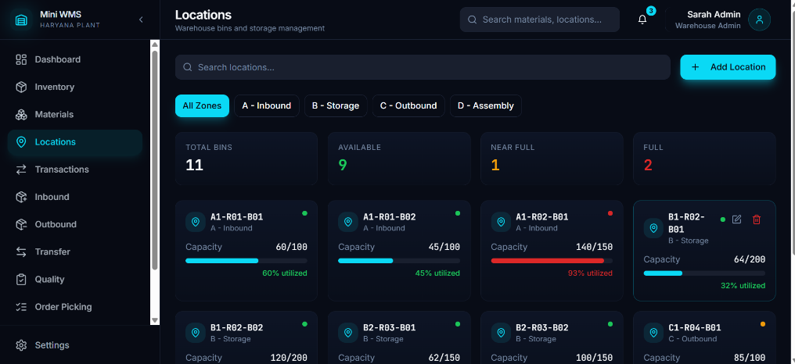

3. Technical Architecture
3.1 Frontend Architecture
- Modular component-based structure
- React Query for server-state management
- Context API for authentication and protected routes
- Responsive layouts with reusable UI components
3.2 Backend Architecture
- MVC pattern for clean separation of concerns
- RESTful API design
- Middleware-based authentication and authorization
- Centralized error handling and logging

4. Features and Functionality
4.1 Authentication and Authorization
- Secure login with bcrypt password hashing
- JWT-based authentication with 7-day expiry
- Role-based access control enforcing permissions
4.2 Dashboard and Analytics
- Six real-time KPIs including inventory accuracy and bin utilization
- Charts and tables with auto-refresh
- Trend analysis and recent transaction feeds
4.3 Material and Inventory Management
- Material categorization and GST configuration
- Real-time stock levels with reserved and available quantities
- Low-stock alerts and batch tracking
4.4 Transaction Management
- INBOUND, OUTBOUND, TRANSFER, and ADJUSTMENT operations
- Automatic GST and sustainability calculations
- Complete audit trail with user attribution
4.5 Location, Order, Quality, and Shipping Modules
- Hierarchical warehouse locations with utilization metrics
- End-to-end order lifecycle management
- Quality inspections with pass/fail workflows
- Shipment tracking with carrier and delivery status
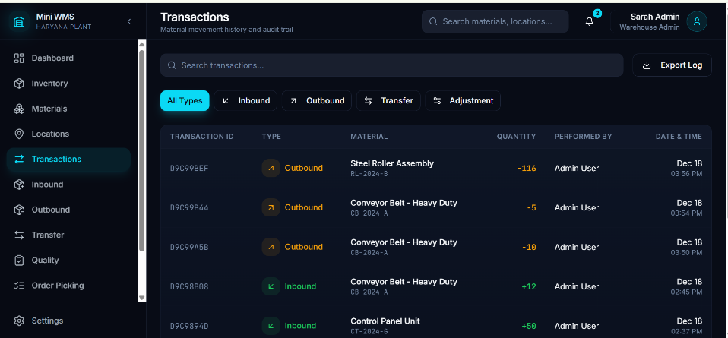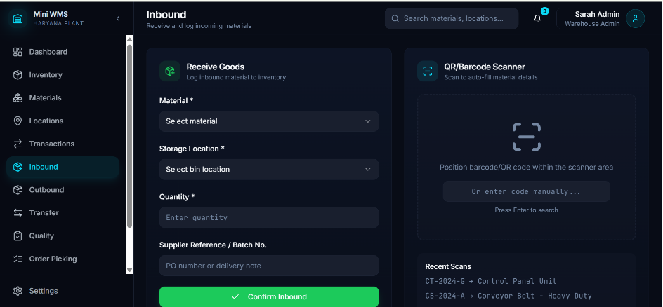

5. Database Design
- 13 MongoDB collections covering core and advanced entities
- Well-defined relationships between users, inventory, transactions, and orders
- Indexed fields for performance optimization
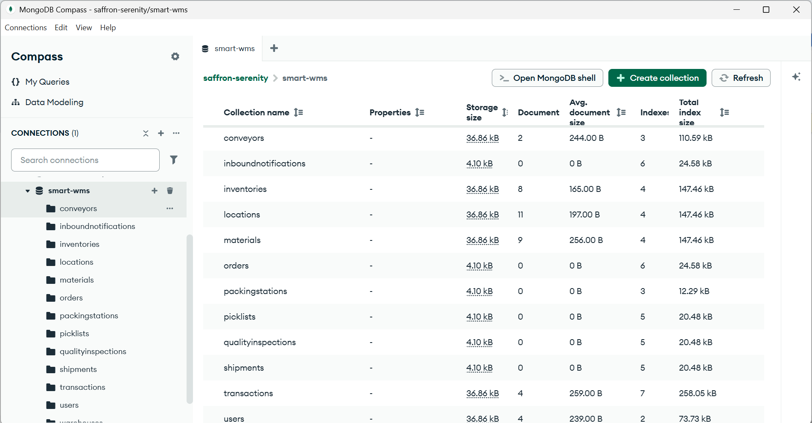

6. API Documentation
- REST APIs for authentication, materials, inventory, transactions, dashboard, orders, and quality
- Secure endpoints protected by JWT middleware
- Consistent request/response structures

7. User Interface
- Modern design system with light and dark modes
- Responsive layouts for desktop and tablet
- User-friendly features including toasts, validations, skeleton loaders, and confirmation dialogs

8. Security Implementation
- bcrypt password hashing and JWT authentication
- Role-based route protection
- Joi-based input validation
- Secure CORS and environment variable management

9. Testing and Quality Assurance
- Functional testing for authentication, transactions, and inventory updates
- Bug fixes for inbound transactions and frontend data handling
- Browser testing on Chrome and Edge

10. Deployment and Configuration
- Separate development and production environments
- Database seeding for initial setup
- Deployment-ready for Vercel, Netlify, AWS, and MongoDB Atlas

11. Known Issues and Resolutions
- MongoDB session limitations resolved for standalone instances
- Polling-based real-time updates (WebSocket planned)
- Mobile optimization and file uploads planned for future releases

12. Future Enhancements
- Barcode/QR scanning and mobile app development
- Conveyor system and IoT integration
- Predictive analytics and multi-warehouse support
- Advanced reporting and AI-driven automation

13. Conclusion
Smart StockFlow is a production-ready warehouse management solution delivering high accuracy, security, and scalability. The system meets current operational needs while providing a strong foundation for future expansion and digital transformation at BEUMER Group.

Appendices
Appendix A: Demo Credentials
Role | Email | Password
Admin | admin@beumer.com | admin123
Operator | john@beumer.com | operator123
Supervisor | sarah@beumer.com | supervisor123
Engineer | mike@beumer.com | engineer123
Appendix B: API Base URLs
- Development: http://localhost:5000/api
- Production: https://api.your-domain.com/api
Appendix C: Documentation References
React, TypeScript, Express.js, MongoDB, Mongoose, TailwindCSS, shadcn/ui

Report Prepared By:Mandeep Rana
Status: Final
Version: 1.0.0

